LAVAZZA PRESENTS ¡TIERRA! BRASILE, ITS NEW SUSTAINABLE BLEND OF THE FOOD SERVICE RANGE, AT GULFOOD 2018

Premium quality and sustainability are joined in the new Lavazza blend from Brazil

Dubai, 18-22 February 2018 - Conveying Lavazza’s expertise and leadership in the coffee sector to businesses, as well a further commitment to sustainability are the starting point from which the Turin-based company is developing its presence at Gulfood 2018 (18-22 February), the world’s largest food event for businesses.

For the third year in a row in the forefront of the international fair, Lavazza will be present with its existing, well-known product range, with displays devoted to its various products for the Café, Restaurant and Hotel sectors. Lavazza is also launching its latest innovative offering for 2018: ¡Tierra! Brasile Espresso, exclusively available for the food service industry. A premium blend obtained by combining the finest Brazilian arabica coffees with washed Conillon, a fine robusta, ¡Tierra! Brasile is mild espresso with an intense personality.
The blend is a concrete example of Lavazza’s commitment to sustainability and its painstaking search for the best coffee selections.
Visitors of Gulfood 2018 are welcome to taste the unique blend during the five-day event.

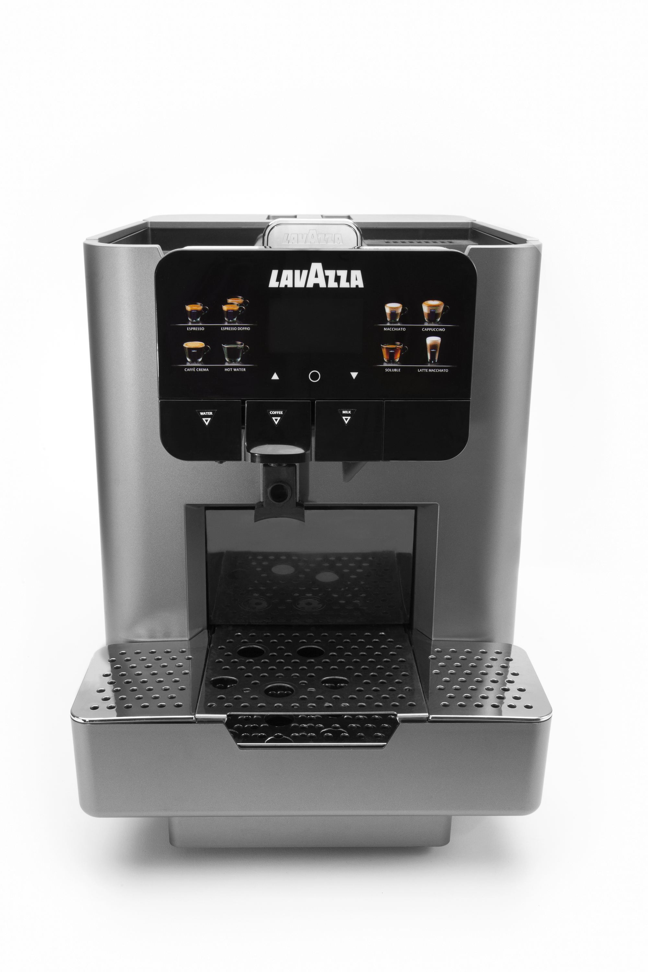
For over 120 years, Lavazza has been working to create coffee blends and make them unique, perfectly combining the body, aromas and flavours recognized worldwide as Lavazza coffee. Lavazza’s Master Blenders, perform many tasting sessions in order to select more than 100 beans from different sources every year, bringing together unique tastes and the finest, most refined flavours to ensure that only the best end product reaches the coffee cup. It is thanks to this excellent art of coffee blending that today the Lavazza ¡Tierra! range for the industry professionals has a new integrated, original offering of outstanding quality: ¡Tierra! Brasile will be available on the market as of May and will join the the ¡Tierra! range already served in the best food service venues.

Besides its premium blends, Lavazza is presenting its LB 2317, its new machine for the food service industry and hotellerie. Manufactured by Saeco, LB 2317 is designed to intensify the experience in every single detail: elegant, professional, technologic, versatile and performant, this model is designed to fit all places from front of house serviced to self service solutions. LB2317 is easy to use, quiet and allows users to choose every day between espresso coffee, macchiato, cappuccino italiano or americano, latte macchiato and more.

¡TIERRA!
Lavazza’s answer to sustainable development
¡Tierra! is a sustainability project launched in 2002 and developed on a joint basis with the Rainforest Alliance NGO, with the aim of improving the social and environmental conditions and the production techniques of several coffee-growing communities.
The ¡Tierra! programme, which embraces projects devised and managed with more direct input from the nonprofit Giuseppe and Lavazza Foundation, is divided chronologically into two periods: in 2009 the first phase was completed, involving three communities in Peru, Honduras and Colombia; the second phase, launched in 2010, is addressed to India, Brasile and Tanzania. Since 2013, the programme has also involved two communities in Ethiopia and Vietnam. In real terms, the projects have created facilities to process coffee and improve efficiency, built and renovated homes, schools and medical centres, launched microcredit projects and, most importantly, developed training programmes in the field for small producers, with the aim of implementing sustainable production techniques. Over the years, the programme has also worked to improve healthcare, as well as providing assistance to bring drinking water to plantations and villages.
The ¡Tierra! project focuses on three key aspects: the quality of the end product, a concern for the living conditions of the people in coffee-producing countries and the protection of the environment. Its goals are to improve the living conditions of farming communities and to develop high quality production processes, accompanied by the gradual reduction of environmental impact through the use of new farming techniques. Today, ¡Tierra! is a comprehensive range of products for both the home and out-of-home markets, containing coffee grown by these communities.

About Lavazza Group
Established in 1895 in Turin, the Italian roaster has been owned by the Lavazza family for four generations. Among the world’s most important roasters, the Group currently operates in more than 90 countries through subsidiaries and distributors, exporting 60% of its production. Lavazza employs a total of about 3,000 people with a turnover of more than €1.9 billion in 2016. Lavazza invented the concept of blending — or in other words the art of combining different types of coffee from different geographical areas — in its early years and this continues to be a distinctive feature of most of its products.
The company also has over 25 years’ experience in production and sale of portioned coffee systems and products. It was the first Italian business to offer capsule espresso systems.
Lavazza operates in all business segments: at home, away-from-home and office coffee service, always with a focus on innovation in consumption technologies and systems. Lavazza has been able to develop its brand awareness through important partnerships perfectly in tune with its brand internationalization strategy, such as those in the world of sport with the Grand Slam tennis tournaments, and those in fields of art and culture with prestigious museums like New York’s Guggenheim Museum, the Peggy Guggenheim Collection Venice, and The Hermitage State Museum in St. Petersburg, Russia.
As the company continues on a strategic globalization path, the Lavazza Group has acquired local jewels in key markets such as France’s Carte Noire (2015), Denmark’s Merrild (2015) and North America’s Kicking Horse Coffee (2017). Additionally, in 2017 the Group amplified its distribution reach with the acquisition of France’s Espresso Service Proximité and Italy’s Nims.

